Atul Girhepunje

# **Capstone Project - Olympics Sports Analysis**



# OVERVIEW

The dataset used for this analysis offers a comprehensive view of the Olympic Games over time. It covers various aspects like sports, participants, medals, and global representation. The dataset consists of interconnected tables that provide insights into the Olympics' evolution, diverse sports, athlete characteristics, and historical significance.

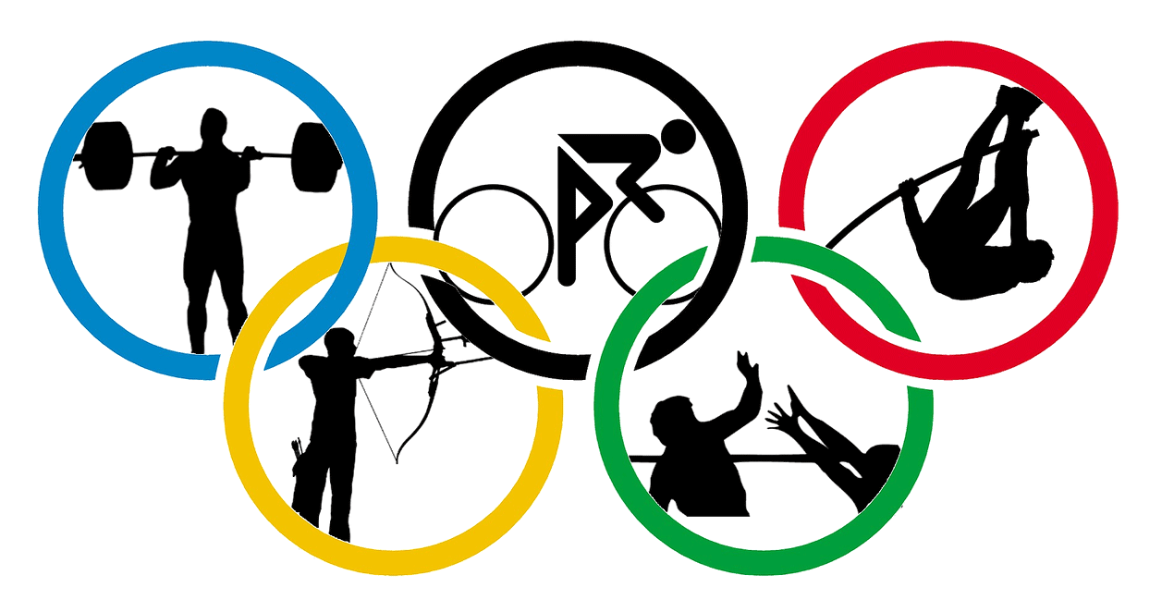

# **THE PROCESS**

**1. Data Acquisition from GitHub:**

Obtain the requisite dataset from a designated GitHub repository, containing essential information on university rankings, encompassing various countries and their performance across distinct ranking systems.

**2. Data Transformation and Enhancement:**

If necessary, execute data transformation procedures to ensure data quality and consistency. Additionally, consider augmenting the dataset with new problem statements to enrich the analysis potential.

**3. Connecting with Tools:**

Establish connections between the dataset and various analytical tools. Interface the dataset with Power BI, Excel, and MySQL Workbench, facilitating seamless data integration and processing.

**4. Problem Statement Solution in Power BI:**

Utilize Power BI to delve into the specified problem statements. Employ its robust features for data visualization, exploration, and analysis, effectively deriving insights and solutions.

**5. Exploratory Data Analysis (EDA):**

Perform exploratory data analysis using either Excel or SQL Workbench, depending on the complexity of the analysis. Extract meaningful patterns, relationships, and trends from the data to inform subsequent decision-making.

**6. Creation of Visual and Insightful PowerPoint:**

Develop a comprehensive PowerPoint presentation that encapsulates the project's objectives, methodologies, problem statement solutions, and key visualizations. Each problem statement should be accompanied by a dedicated section with pertinent conclusions and insights.

**7. Detailed Documentation:**

Compile a detailed report that meticulously documents the entire project lifecycle. Include sections on data collection, transformation, problem statement formulation, tools integration, Power BI solutions, EDA insights, and PowerPoint visualizations.

# **Project Overview**

The Olympic Games hold a special place in global culture, celebrating human athleticism, camaraderie, and diversity. This analysis embarks on a journey through the annals of history, delving into a comprehensive dataset that encapsulates the essence of the Olympics across its various dimensions.

The primary objective is to extract valuable insights from the data, revealing trends, patterns, and significant shifts in the landscape of this prestigious international sporting event. By delving into various facets of the Games, including their seasons, hosts, sports, participants, medals, and global representation, this project aspires to uncover profound insights, patterns, and trends that have shaped the Olympics' rich history.

Dataset underpinning this exploration spans the years from 1996 to 2016, offering a comprehensive view of the Games during this period. This selective timeframe allows us to focus our analysis on a significant portion of modern Olympic history, showcasing how the event has evolved and impacted the world over two decades.

Exploring Olympic Data: Look at Olympics history, including sports, participants, medals, and more. Find patterns and trends in the data.

Comparing Seasons and Hosts: Check how many Summer and Winter Olympics happened. See which cities hosted the most Games.

Sports and Athletes: Find out which sports have the most events and how athlete participation has changed.

Gender and Medals: Look at events for men, women, and mixed genders. Study which countries win the most medals.

Global Diversity: Check how many regions join each Olympics. See which regions have the most athletes.

Ages of Athletes: Check how old athletes are in different Games.

Summarize Findings: Put together what you learned from the data, highlighting important things.

Recommend Improvements: Suggest ways to make future Olympics better based on what you found.

# **Significance**

Valuable Insights: Analyzing the Olympics database yields valuable insights into the historical data of the Olympic Games. Researchers can extract trends, patterns, and performance metrics from various dimensions like games, sports, events, participants, medals, and regional representation. These insights help stakeholders understand the Games' impact, identify standout athletes, and recognize influential sporting events.

Improvement Focus: By evaluating past Olympic Games editions, the analysis can shed light on areas that require improvement. Insights into host city selection, sports popularity, and regional representation can guide future Olympics organizers in making informed decisions to enhance the Games' overall experience and relevance.

Evaluation of Effectiveness: The Olympics database analysis allows for an assessment of the effectiveness of past Games editions. Researchers can evaluate the impact of specific events, the success of diverse sports, and the distribution of medals among different countries. This evaluation aids in understanding the Games' global reach and significance in fostering international sportsmanship.

Trend Identification: The analysis of historical Olympic data enables the identification of long-term trends and changes in the Games. Researchers can uncover trends in host city preferences, the introduction or removal of sports disciplines, and shifts in the geographic representation of participating countries. Understanding trends assists in predicting future developments and adapting strategies accordingly.

Comprehensive Understanding: The Olympics database analysis offers a comprehensive understanding of the Games' evolution and historical significance. By examining multiple aspects of the Olympics, researchers gain a holistic view of how the Games have evolved over time and how they have shaped the world's sporting landscape.

In conclusion, the significance of analyzing the Olympics database lies in its potential to provide valuable insights, guide improvements, evaluate effectiveness, identify trends, and offer a comprehensive understanding of the historical Olympic Games. This analysis contributes to the appreciation of the Games' global impact and aids in strategic decision-making for future editions.

# **Data Dictionary:**

**City Table**

Fields:

Id- Unique identifier for each city

city_name- Name of the city

**competitor_event Table**

Fields:

event_id- Foreign key referencing the event_id field in the events table

competitor_id- Foreign key referencing the competitor _id field in the games competitor table

medal_id- Foreign key referencing the medal_id field in the medal table

**event Table**

Fields:

Id- Unique identifier for each event

sport_id- Foreign key referencing the sport_id field in the event table

event_name- name of the event

**games Table**

Fields:

Id- Unique identifier for each game table

games_year- year of games

games_name- name of year and season

season- name of season winter or summer

**games_city Table**

Fields:

games_id- Foreign key referencing the game_id field in the games Table

city_id- Unique identifier for each game city table

**games_competitor Table**

Fields:

Id- Unique identifier for each games_competitor Table

games_id- Foreign key referencing the game_id field in the games Table

person_id- Foreign key referencing the person_id field in the person Table

age- age of the person

**medal Table**

Fields:

Id- Unique identifier for each medal Table

medal_name- name of the medal

**noc_region Table**

Fields:

Id- Unique identifier for each noc_region Table

Noc- short name for the noc region name

region_name- name of the region

**person Table**

Fields:

Id- Unique identifier for each person Table

full_name- full name of the person

gender- gender of the person

height- height of person

weight- weight of person

**person_region Table**

Fields:

person_id- Foreign key referencing the person_id field in the person Table

region_id- Foreign key referencing the region_id field in the sports Table

**sport Table**

Fields:

Id- Unique identifier for each sports Table

sport_name- name of the sports

The data dictionary provides a comprehensive overview of the tables and their respective fields in the dataset. It outlines the relationships between the tables, allowing for a better understanding of the data structure and facilitating the design and implementation of the Power BI Dashboard.

# **ER diagram**



# **Power BI Problem Statements**

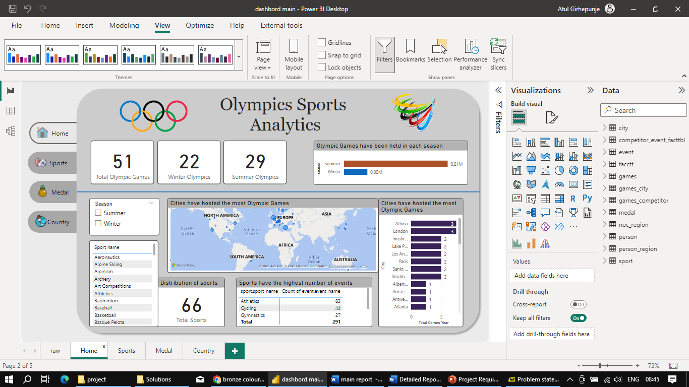

### 1. How many Olympic Games have been held in each season (Summer vs. Winter)?

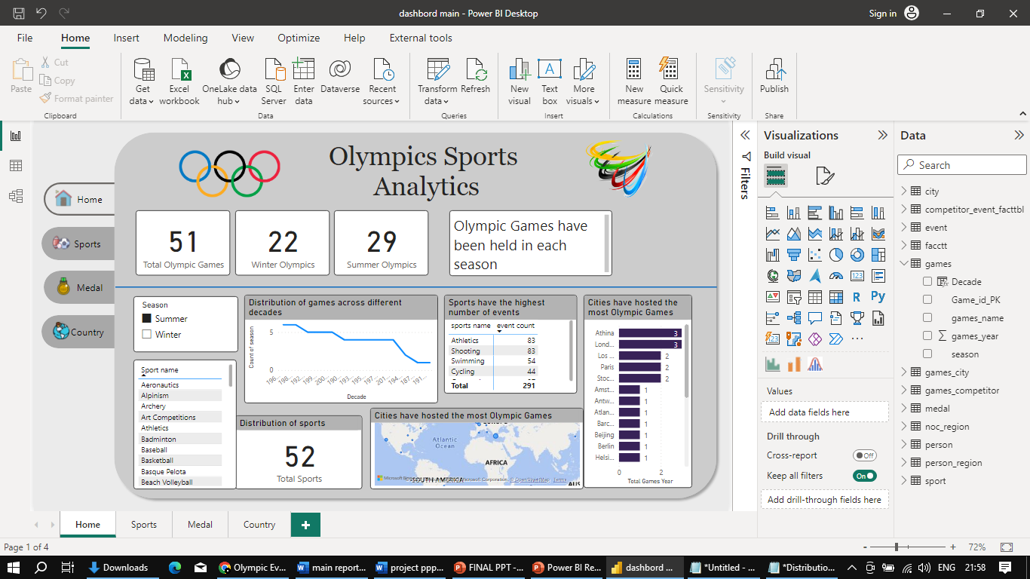

The Olympic Games have been held in two seasons: Summer and Winter. The Summer Olympics have been held 29 times since 1896, and the Winter Olympics have been held 22 times since 1924.

The Summer Olympics are the more popular of the two events, with more countries participating and more spectators watching. The Winter Olympics are smaller in scale, but they are still a major international sporting event.

The Summer Olympics are held every four years, while the Winter Olympics are held every four years but two years after the Summer Olympics. This means that there is an Olympic Games every two years, but one is always a Summer Olympics and the other is always a Winter Olympics.

### 2. What is the distribution of games across different decades?

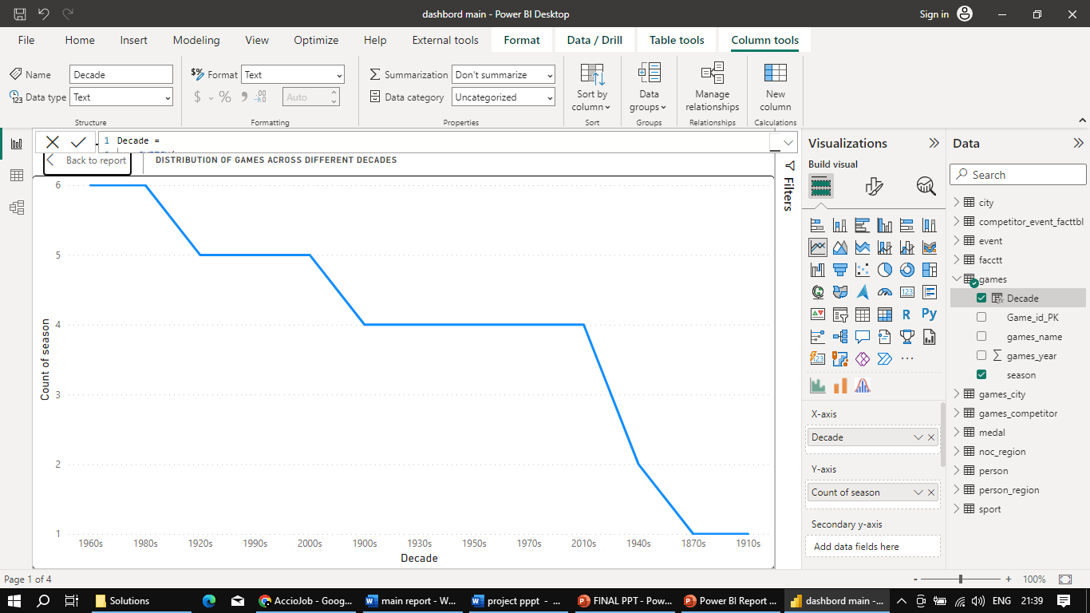

The distribution of Olympic Games across decades paints a vivid picture of their evolution. The 1870s saw a single season, marking early steps in organized sports. The 1900s and 1910s brought more structured events despite disruptions. The 1920s roared with five seasons amid cultural growth, while the 1930s persisted with four seasons despite the Great Depression. World War II limited the 1940s to two seasons, followed by resurgent popularity in the 1950s to 1980s, with 4-6 seasons each. The 1990s, 2000s, and 2010s maintained a steady four seasons, symbolizing sports' timeless global influence.

### 3. Which cities have hosted the most Olympic Games?

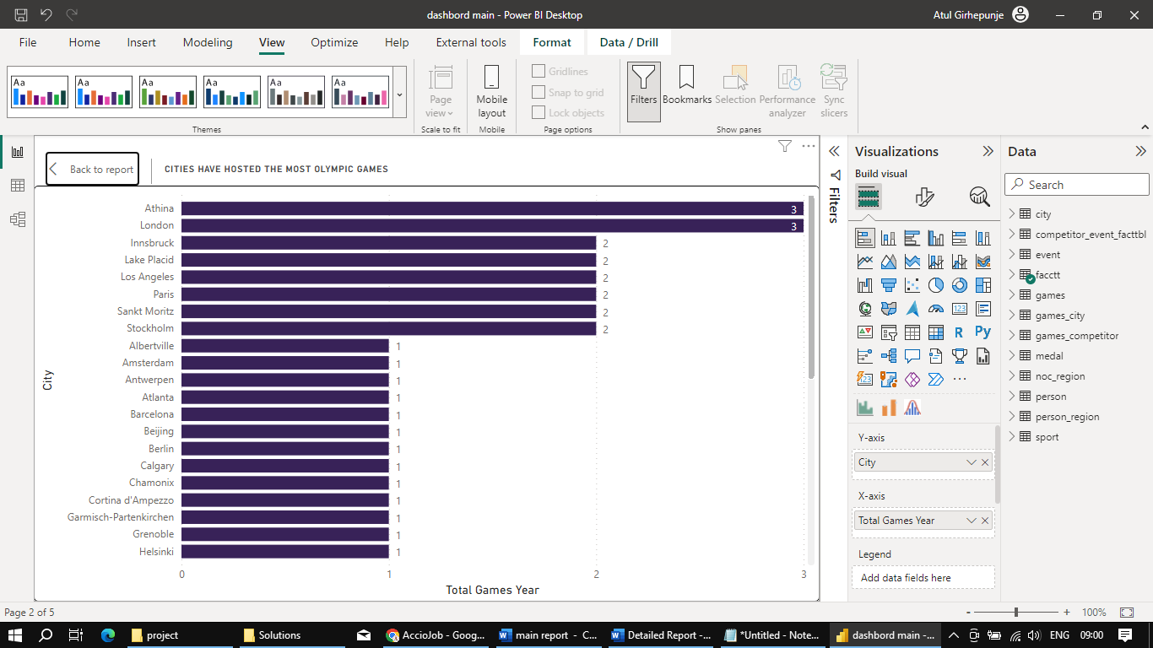

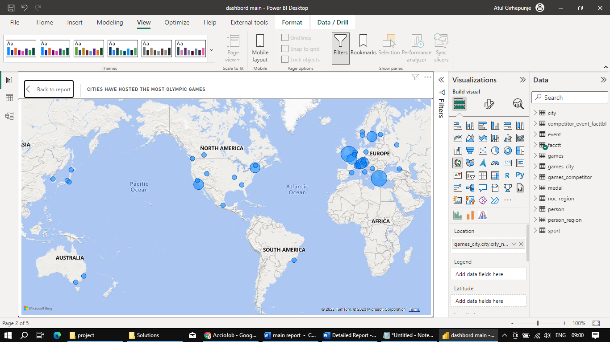

The cities that have hosted the most Olympic Games, each with a count of 3 times, are Athina and London. These two exceptional cities have had the honor of hosting the Olympics three times, a testament to their historical significance, cultural vibrancy, and their ability to foster the spirit of global athletic camaraderie.

* When we examine the breakdown by seasons, we find that both Athina and London have hosted the Summer Olympic Games three times each. These iconic cities have not only showcased exceptional hosting capabilities but have also contributed significantly to the legacy of the Summer Olympics.
* In Winter Olympics, there is a trio of cities that have each hosted twice: Innsbruck, Lake Placid, and Sankt Moritz. These cities have been selected twice to bring to life the awe-inspiring Winter Games, showcasing their suitability for winter sports and the ability to create remarkable Olympic experiences.

Athina and London hold the record for the most Olympic Games hosted, with each city hosting three times. Their contributions to the Olympic movement, along with other cities like Innsbruck, Lake Placid, and Sankt Moritz, have enriched the Games' legacy and left an indelible mark on the world of sports and international unity.

### 4. What is the distribution of sports between Summer and Winter Olympics?

The distribution of sports between the Summer and Winter Olympics showcases a diverse array of athletic disciplines that span the spectrum of human capability. With a total of 66 sports encompassing both seasons, the Olympic Games offer a comprehensive stage for athletes to demonstrate their skills, determination, and dedication to their craft.

Summer Olympics Sports:

The Summer Olympics host a wide range of sports that cater to different strengths and abilities. From classics like Athletics, Gymnastics, and Swimming, which highlight physical prowess, to team-based games like Football, Basketball, and Volleyball that emphasize teamwork and strategy, the Summer Olympics are a testament to human athleticism and camaraderie. Additionally, unique sports such as Synchronized Swimming, Taekwondo, and Triathlon add a distinctive flavor to the mix. In total, there are 51 sports featured in the Summer Olympics, covering a multitude of talents and disciplines.

Winter Olympics Sports:

The Winter Olympics provide a platform for athletes to showcase their expertise in cold-weather sports. Events like Alpine Skiing, Figure Skating, and Ice Hockey captivate audiences with their grace and speed, while sports like Curling, Bobsleigh, and Skeleton demand precision and technique. These sports emphasize skill, balance, and control in challenging winter conditions. In total, the Winter Olympics feature 15 sports that embrace the unique challenges and thrills of winter sportsmanship.

Both the Summer and Winter Olympics demonstrate the dedication and passion of athletes from around the world. Together, these events celebrate the beauty of human movement, diversity, and the pursuit of excellence across an impressive array of sporting disciplines.

### 5. Which sports have the highest number of events in the Olympics?

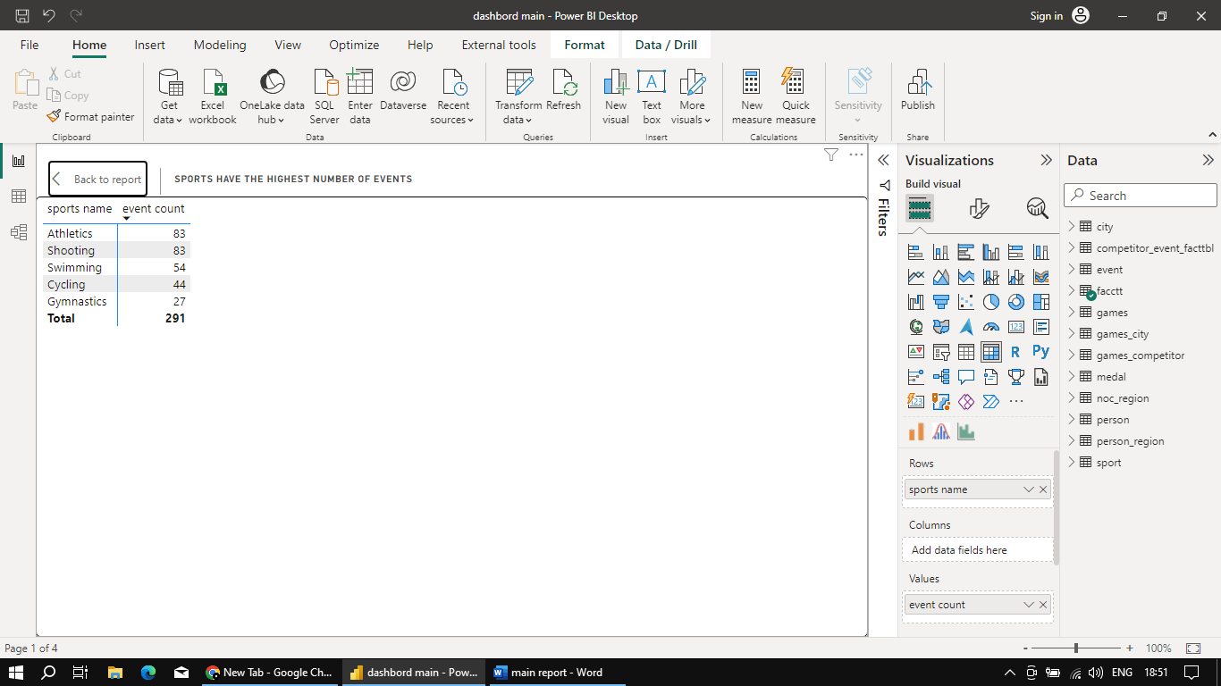In the Olympic Games, various sports take centre stage to showcase the incredible diversity of human abilities and talents. When examining the distribution of events across different sports, I find that some sports have a higher number of events, offering athletes multiple opportunities to compete and excel on the grand stage. Here's a comprehensive breakdown of the sports with the highest number of events in the Olympics:

1. Athletics (83 Events): Athletics, often considered the cornerstone of the Olympics, offers a staggering 83 events. From sprints to marathons, jumps to throws, and relays to multi-discipline events like the decathlon and heptathlon, Athletics encapsulates a wide range of physical talents and disciplines.

2. Swimming (54 Events): Swimming boasts 54 events, covering various strokes, distances, and relays. From the exhilaration of sprint races to the endurance of long-distance swims, Swimming showcases the beauty and power of human movement through water.

3. Shooting (83 Events): With an equal number of events as Athletics, Shooting demonstrates precision and accuracy across a multitude of firearm disciplines. From pistols to rifles and shotguns, athletes compete in events that test their marksmanship under different conditions.

4. Cycling (44 Events): Cycling encompasses 44 events, ranging from road races to track events, mountain biking, and BMX races. These events showcase speed, endurance, and technical skill on various terrains and surfaces.

5. Sailing (37 Events): Sailing offers 37 events across different classes of boats and varying conditions. Athletes harness wind and water to maneuver their vessels, showcasing mastery over natural elements.

6. Canoeing (27 Events): Canoeing features 27 events, encompassing sprint and slalom races. Athletes navigate water courses with speed and precision, demonstrating their control over both their vessels and the water currents.

7. Gymnastics (27 Events): Gymnastics involves a total of 27 events, combining artistic expression and physical prowess. These events include artistic gymnastics, rhythmic gymnastics, and trampoline, each highlighting different aspects of grace and strength.

8. Wrestling (30 Events): Wrestling comprises 30 events, showcasing both freestyle and Greco-Roman styles. Athletes engage in intense bouts of strength, strategy, and technique.

These sports with the highest number of events not only highlight the versatility of athletes but also contribute to the diversity and richness of the Olympic experience. From individual prowess to team dynamics, these events collectively embody the essence of the Games – excellence, unity, and the celebration of human potential.

### 6. How has the participation in each sport evolved over time?

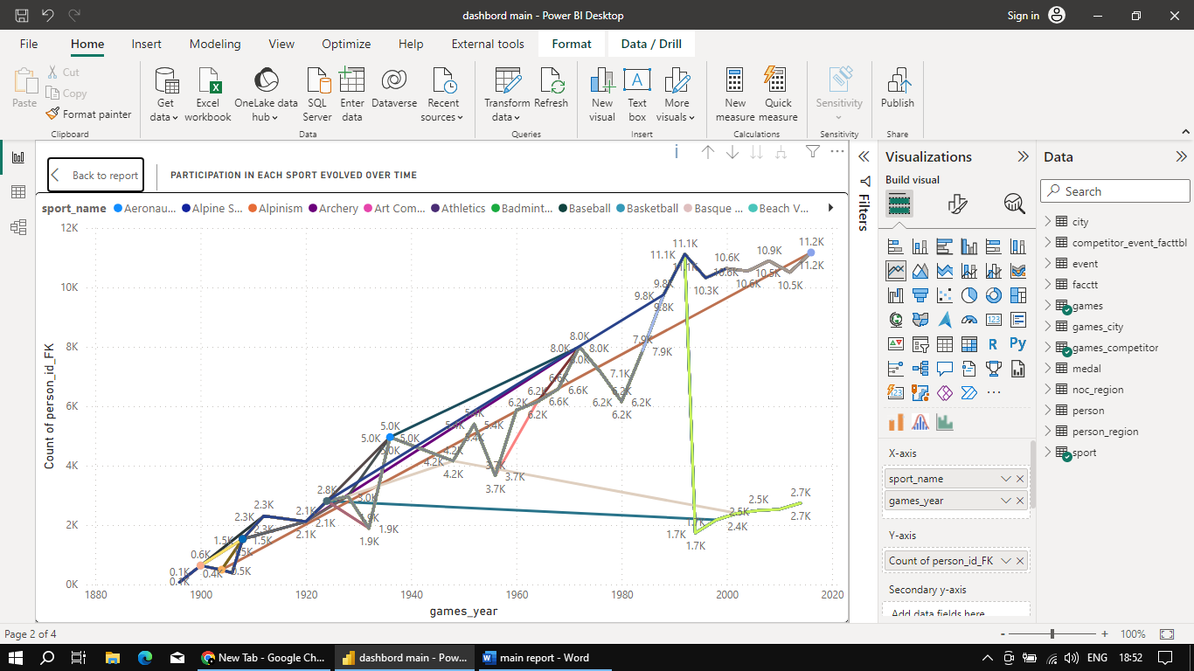

Here is the trends for some selected sports:

Athletics (Track and Field):

Athletics has consistently been a popular sport across multiple Olympic Games. The number of participants has generally increased over the years, reflecting its enduring popularity.

Swimming:

Similar to athletics, swimming has maintained steady participation and popularity over various editions of the Olympics.

Gymnastics:

Gymnastics, another long-standing sport in the Olympics, has also experienced stable participation, with slight fluctuations in the number of participants over different years.

Basketball:

Basketball participation has shown a consistent upward trend over the years, with a notable increase in the number of participants in recent editions of the Olympics.

Cycling:

Cycling has seen varying levels of participation over the years, with some fluctuations. There has been a general upward trend, especially in recent years.

Football (Soccer):

Football has had significant participation, but there are instances where the number of participants has fluctuated, possibly due to factors such as host country interest and regional popularity.

Tennis:

Tennis participation has experienced fluctuations over time, with periods of inclusion and exclusion from the Olympic Games affecting the number of participants.

Rowing:

Rowing has maintained consistent participation, with fluctuations in the number of participants across different editions of the Olympics.

Volleyball:

Volleyball has shown a steady increase in participation over the years, reflecting its popularity as a team sport.

Wrestling:

Wrestling has maintained relatively stable participation, with some fluctuations in the number of participants across various editions of the Olympics.

### 7. How many events are there in each sport?

|  |  |  |  |  |
| --- | --- | --- | --- | --- |
| sport name | Events |  | sport name | Events |
| Aeronautics | 1 |  | Judo | 15 |
| Alpine Skiing | 10 |  | Lacrosse | 1 |
| Alpinism | 1 |  | Luge | 4 |
| Archery | 25 |  | Military Ski Patrol | 1 |
| Art Competitions | 29 |  | Modern Pentathlon | 3 |
| Athletics | 83 |  | Motorboating | 3 |
| Badminton | 5 |  | Nordic Combined | 5 |
| Baseball | 1 |  | Polo | 1 |
| Basketball | 2 |  | Racquets | 2 |
| Basque Pelota | 1 |  | Rhythmic Gymnastics | 2 |
| Beach Volleyball | 2 |  | Roque | 1 |
| Biathlon | 13 |  | Rowing | 23 |
| Bobsleigh | 4 |  | Rugby | 1 |
| Boxing | 15 |  | Rugby Sevens | 2 |
| Canoeing | 27 |  | Sailing | 37 |
| Cricket | 1 |  | Shooting | 83 |
| Croquet | 3 |  | Short Track Speed Skating | 8 |
| Cross Country Skiing | 23 |  | Skeleton | 2 |
| Curling | 2 |  | Ski Jumping | 4 |
| Cycling | 44 |  | Snowboarding | 12 |
| Diving | 10 |  | Softball | 1 |
| Equestrianism | 18 |  | Speed Skating | 13 |
| Fencing | 18 |  | Swimming | 54 |
| Figure Skating | 6 |  | Synchronized Swimming | 3 |
| Football | 2 |  | Table Tennis | 6 |
| Freestyle Skiing | 10 |  | Taekwondo | 8 |
| Golf | 3 |  | Tennis | 9 |
| Gymnastics | 27 |  | Trampolining | 2 |
| Handball | 2 |  | Triathlon | 2 |
| Hockey | 2 |  | Tug-Of-War | 1 |
| Ice Hockey | 2 |  | Volleyball | 2 |
| Jeu De Paume | 1 |  | Water Polo | 2 |
| Wrestling | 30 |  | Weightlifting | 21 |

### 8. What is the distribution of events by gender

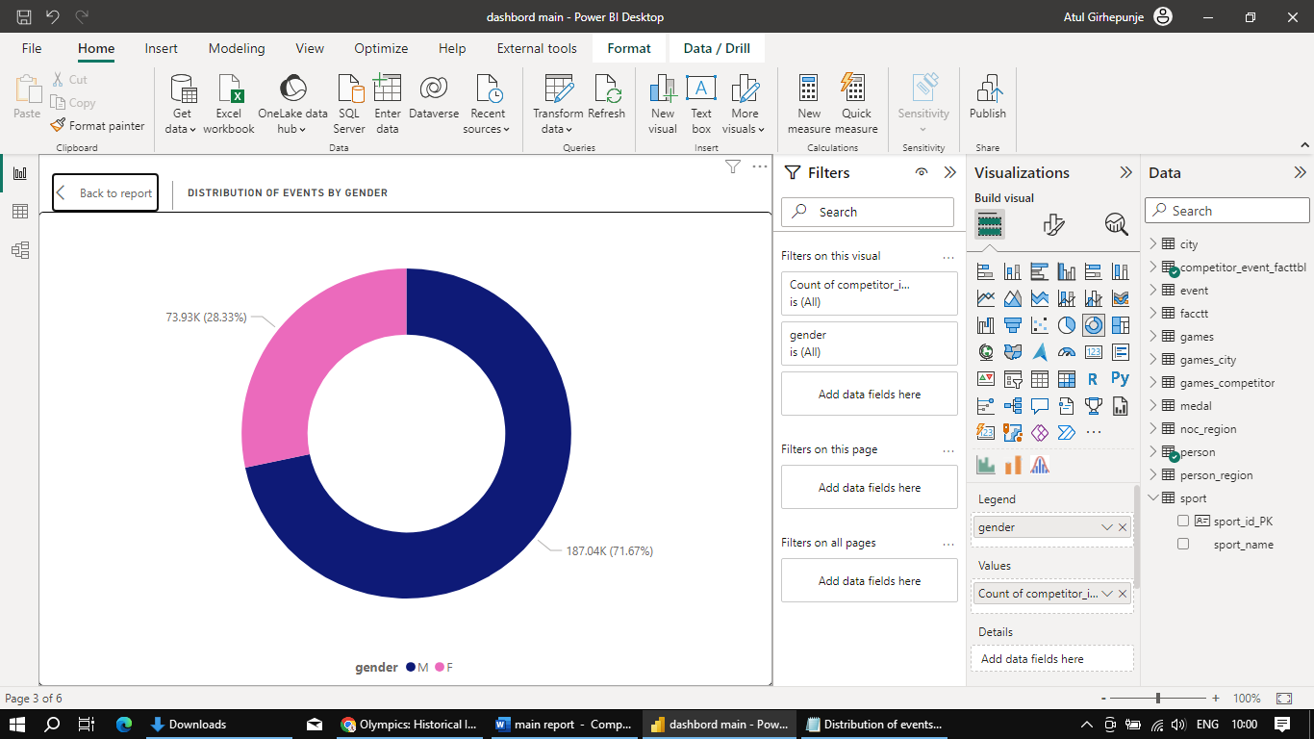

The distribution of events by gender in the Olympic Games is as follows:

Male (M): 187,037 events

Female (F): 73,934 events

This distribution represents the count of competitor IDs in each gender category across various Olympic events. The data indicates that there have been more male events compared to female events in the Olympic Games. This distribution reflects the historical trends and disparities that have existed in the number of events available to male and female athletes in the Olympics.

Over the years, efforts have been made to achieve a more balanced representation of gender in the Olympics, with a focus on increasing the number of events and opportunities for female athletes. As a result, the disparity between male and female events has been gradually narrowing, but it might still be apparent in the data due to the historical context of the Games.

### 9. How has the number of events changed over time?

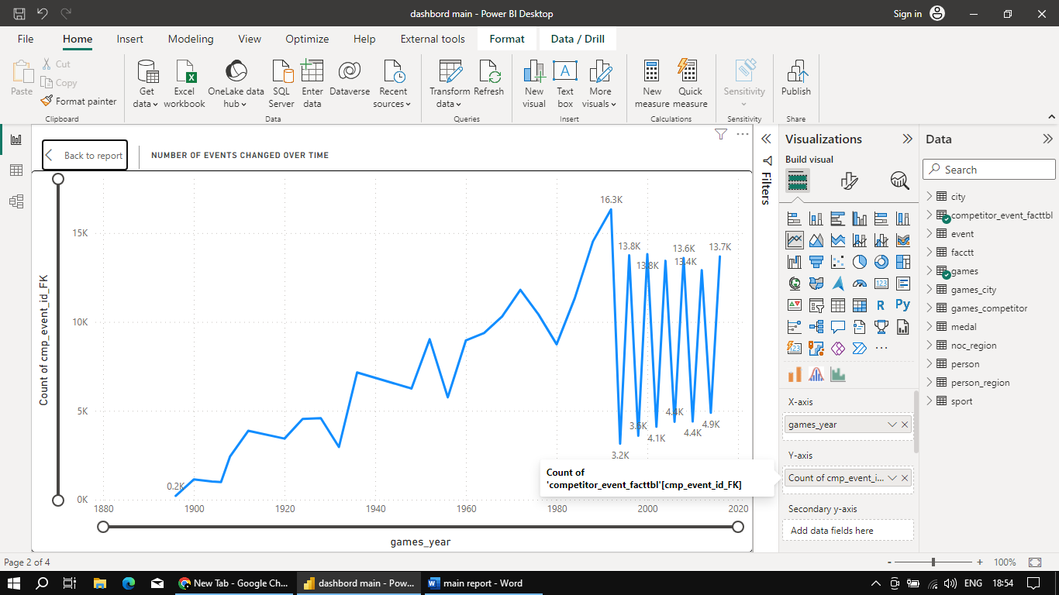

The number of events in the Olympic Games has changed significantly over time. Here is an overview of how the number of events has evolved across all years, as well as specifically for summer and winter Olympics:

Total Number of Events Over the Years:

In 1896, there were 217 events.

The number of events increased over subsequent years, with fluctuations.

The number reached its peak in 2016 with 13,685 events.

Summer Olympics:

The summer Olympics have consistently had more events compared to the winter Olympics.

In the first modern Olympic Games in 1896, there were 217 events.

The number of events increased over the years, with fluctuations.

The number of events reached its peak in the 2016 summer Olympics with 13,685 events.

Winter Olympics:

The winter Olympics started in 1924 and had a smaller number of events compared to the summer Olympics.

The number of events in the winter Olympics also increased over time, with fluctuations.

The number of events reached its peak in the 2014 winter Olympics with 4,888 events.

The number of events in both summer and winter Olympics has generally shown an upward trend over the years, reflecting the growth and diversification of sports and competitions in the Olympics.

There have been fluctuations in the number of events, likely due to various factors such as the introduction of new sports, changes in the event programs, and external circumstances.

The number of events in the summer Olympics has consistently been higher than in the winter Olympics, mainly because the summer Olympics encompass a broader range of sports and activities.

### 10. What is the distribution of participants by gender?

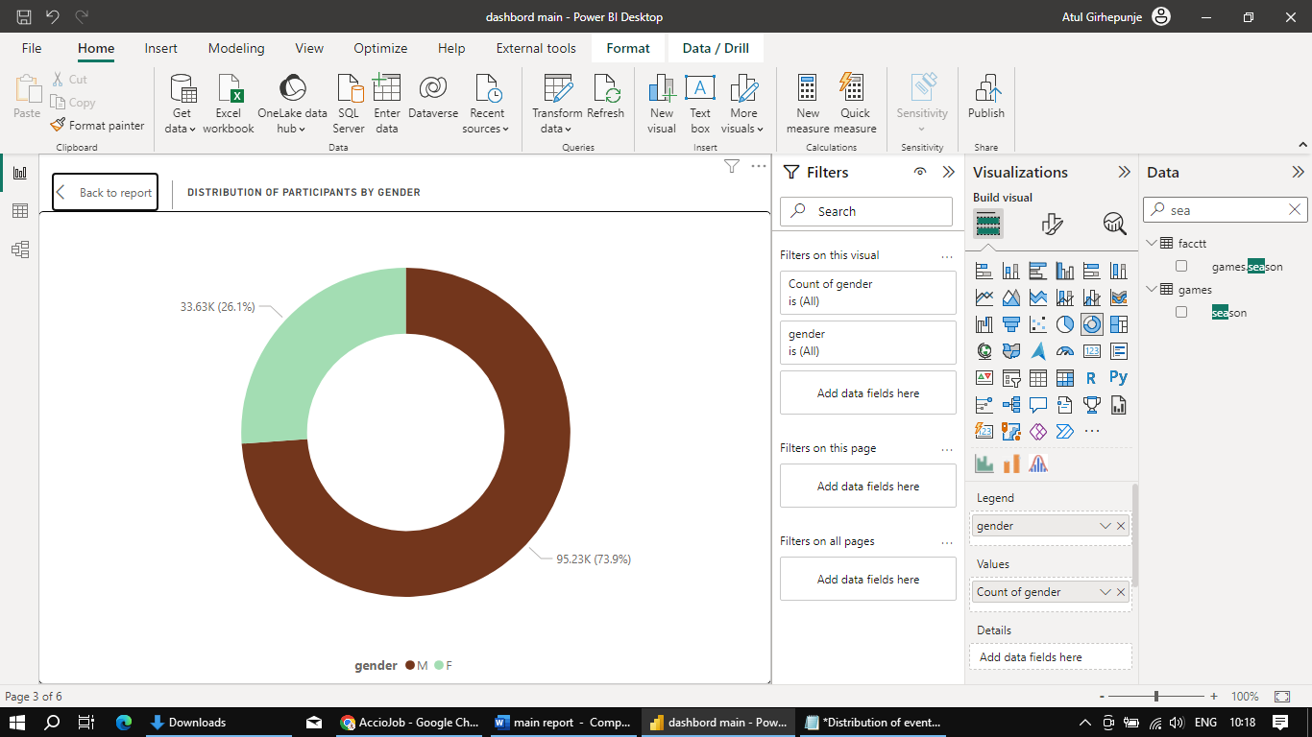

The distribution of participants by gender in the Olympic Games is as follows:

Male participants (M): 95,225

Female participants (F): 33,629

This data indicates that there has been a higher number of male participants compared to female participants in the Olympic Games. However, it's important to recognize that efforts have been ongoing to promote gender equality and increase female participation in the games over the years.

### 11. Which countries have the highest number of participants in the Olympics?

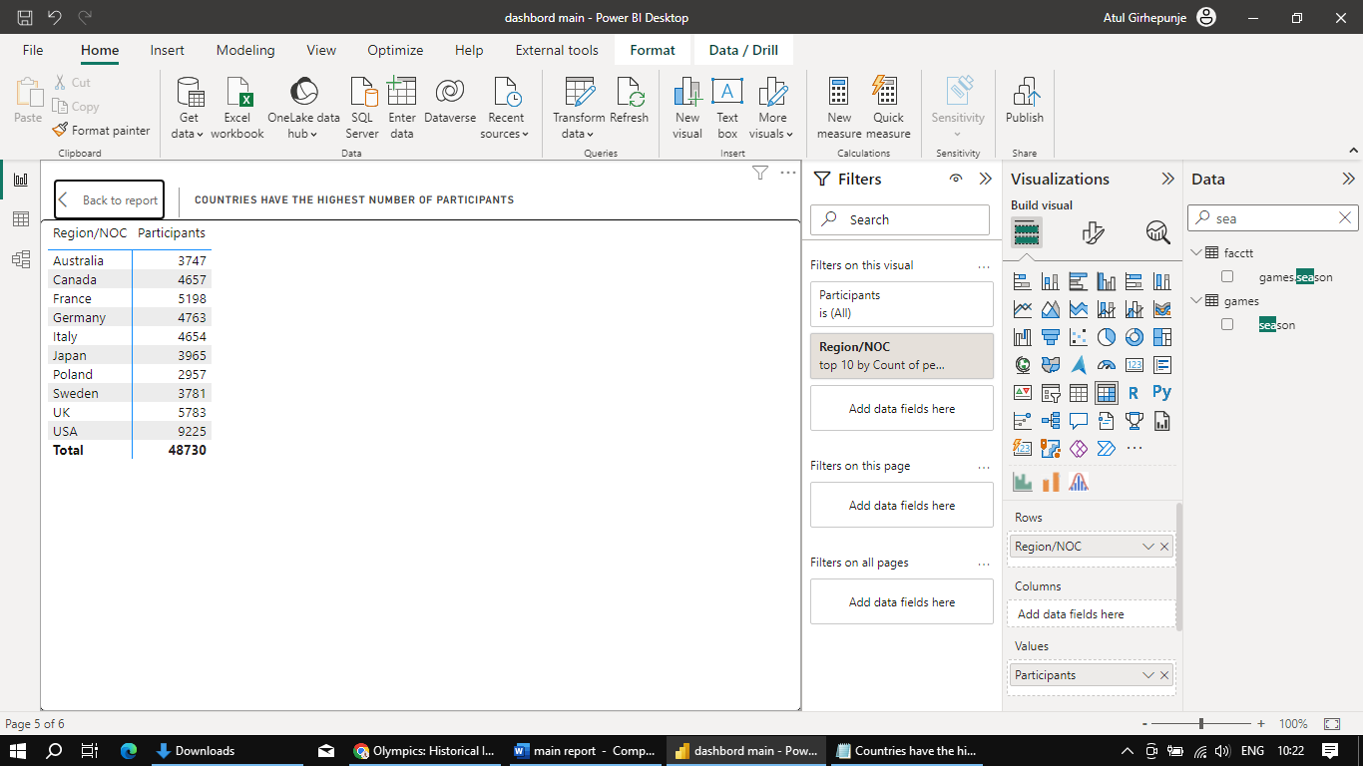

1. **USA (United States) 5,783 participants:** The United States consistently ranks among the top nations with the highest number of participants in the Olympics. With a diverse sports culture and a strong tradition of athletic excellence, the USA has a wide representation across various sports such as athletics, swimming, gymnastics, basketball, and more. The country's well-developed sports infrastructure, training programs, and large population contribute to its high participant count.
2. **UK (United Kingdom) 5,198 participants:** The United Kingdom has a rich Olympic history and often performs well in sports like rowing, sailing, cycling, and athletics. The country's passion for sports and its investment in Olympic training programs have led to a substantial number of participants in the Games. London has hosted the Olympics multiple times, further boosting participation interest.
3. **France 5,198 participants:** France's strong sporting culture and history have resulted in a significant number of participants in the Olympics. Sports such as fencing, judo, cycling, and football have a substantial following in France. The country's commitment to promoting sports and nurturing young talents contributes to its consistent presence in the Games.
4. **Germany 4,763 participants:** Germany, known for its excellence in sports like athletics, swimming, gymnastics, and winter sports, consistently participates with a large contingent in the Olympics. The country's well-established sports associations, training centers, and a robust sports ecosystem contribute to its high participant count.
5. **Italy 4,654 participants:** Italy's passion for sports such as football, cycling, fencing, and winter sports translates into a substantial presence in the Olympics. The country's strong emphasis on grassroots sports development, along with its historical significance in various sports, ensures a consistent representation in the Games.
6. **Canada 4,657 participants:** Canada has a diverse sporting culture with a focus on ice hockey, winter sports, athletics, and rowing. The country's geographical location and climate make it excel in winter disciplines. The Canadian government's support for sports and the development of world-class athletes has led to a consistent participation rate in the Olympics.
7. **Australia 3,747 participants:** Australia's outdoor lifestyle and focus on sports like swimming, rugby, cricket, and sailing contribute to its significant presence in the Olympics. The country's successful sports development programs, investment in athlete training, and hosting of major sporting events have all played a role in maintaining a high level of participation.
8. **Japan 3,965 participants:** As a nation with a deep-rooted sporting heritage, Japan has a substantial presence in the Olympics. The country's proficiency in sports like judo, gymnastics, table tennis, and swimming, combined with its advanced sports facilities, ensures a consistent representation in the Games.
9. **Sweden 3,781 participants:** Sweden's emphasis on sports like athletics, ice hockey, skiing, and football results in a notable participation in the Olympics. Despite its smaller population compared to some other countries on the list, Sweden's strong tradition in winter sports and consistent focus on athletic development contribute to its high participant count.
10. **Poland 2,957 participants:** Poland's passion for sports such as athletics, weightlifting, swimming, and volleyball translates into a significant presence in the Olympics. The country's dedication to fostering sports talent and its achievements in various disciplines have led to a consistent representation in the Games.

These countries' consistent high participation rates are a testament to their strong sports cultures, investment in athlete development, and commitment to promoting a healthy and active lifestyle among their citizens.

### 12. How does the age distribution of participants vary across different games?

The age distribution of participants varies across different sports in the Olympic Games. Average age distribution varies based on the data:

1. **Older Age Groups:** Sports like Roque, Art Competitions, Alpinism, Polo, and Equestrianism tend to have relatively older participants. These sports might require specialized skills and experiences that often come with age.
2. **Middle Age Groups:** Sports like Shooting, Motorboating, Curling, and Sailing have participants with an average age in the early to mid-30s. These sports may require a combination of skill, precision, and experience that tend to accumulate over time.
3. **Diverse Age Groups:** Many sports like Athletics, Gymnastics, Swimming, Fencing, Archery, Rowing, and Basketball have a diverse range of ages. These sports attract participants across different age groups, with factors such as training, specialization, and athletic peak playing a role in the age distribution.
4. **Youth-Centric Sports:** Sports like Rhythmic Gymnastics, Figure Skating, Synchronized Swimming, and Diving have participants with relatively lower average ages. These sports often require high levels of flexibility, agility, and early specialization.
5. **Winter Sports:** Sports like Ski Jumping, Speed Skating, Snowboarding, and Nordic Combined have participants with an average age in the mid-20s. These sports can require a mix of technical skill and physical conditioning that peaks in the mid-20s.
6. **Combat and Martial Arts:** Combat sports like Boxing, Judo, and Taekwondo have participants with an average age in the mid-20s to early 30s. These sports require a good balance of strength, speed, and technique.
7. **Team Sports:** Team sports like Football, Hockey, and Volleyball attract participants with an average age in the mid-20s to late 20s. These sports involve a combination of skill, coordination, and teamwork, often peaking in the mid-20s.
8. **Individual Sports:** Individual sports like Tennis, Badminton, and Weightlifting attract participants with an average age in the mid-20s. Skill, strength, and technique play a significant role in these sports.
9. **Less Common Sports:** Sports like Aeronautics, Basque Pelota, and Military Ski Patrol have a smaller sample size and thus may have more varied age distributions.

### 13. How many medals have been awarded in each Olympics?

|  |  |  |  |  |
| --- | --- | --- | --- | --- |
| **Year** | **Gold** | **Silver** | **Bronze** | **Total Medal** |
| 1896 | 52 | 30 | 20 | **102** |
| 1900 | 179 | 160 | 129 | **468** |
| 1904 | 158 | 133 | 126 | **417** |
| 1906 | 127 | 98 | 85 | **310** |
| 1908 | 284 | 244 | 237 | **765** |
| 1912 | 326 | 313 | 296 | **935** |
| 1920 | 462 | 401 | 312 | **1175** |
| 1924 | 313 | 309 | 274 | **896** |
| 1928 | 269 | 253 | 271 | **793** |
| 1932 | 249 | 234 | 224 | **707** |
| 1936 | 340 | 346 | 325 | **1011** |
| 1948 | 318 | 326 | 318 | **962** |
| 1952 | 342 | 334 | 345 | **1021** |
| 1956 | 641 | 632 | 640 | **1913** |
| 1960 | 354 | 348 | 366 | **1068** |
| 1964 | 420 | 421 | 415 | **1256** |
| 1968 | 435 | 420 | 430 | **1285** |
| 1972 | 478 | 458 | 493 | **1429** |
| 1976 | 514 | 508 | 520 | **1542** |
| 1980 | 539 | 544 | 555 | **1638** |
| 1984 | 582 | 565 | 592 | **1739** |
| 1988 | 777 | 716 | 753 | **2246** |
| 1992 | 824 | 775 | 849 | **2448** |
| 1994 | 137 | 133 | 120 | **390** |
| 1996 | 656 | 668 | 677 | **2001** |
| 1998 | 167 | 164 | 161 | **492** |
| 2000 | 699 | 690 | 718 | **2107** |
| 2002 | 164 | 163 | 168 | **495** |
| 2004 | 670 | 688 | 706 | **2064** |
| 2006 | 181 | 180 | 180 | **541** |
| 2008 | 677 | 677 | 727 | **2081** |
| 2010 | 174 | 172 | 174 | **520** |
| 2012 | 635 | 634 | 687 | **1956** |
| 2014 | 209 | 200 | 199 | **608** |
| 2016 | 668 | 660 | 710 | **2038** |

This data shows the count of each type of medal awarded in various Olympic Games.

### 14. Which countries have the highest number of gold medals?

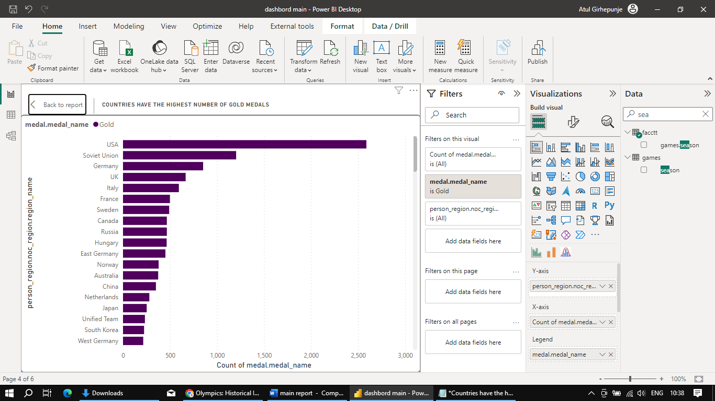

countries with the highest number of gold medals in Olympic history:

1. **United States (USA):** Leading with 2588 gold medals, the USA's diverse athletic excellence and strong sports culture contribute to its dominant position in Olympic history.
2. **Soviet Union:** With 1203 gold medals, the Soviet Union's Cold War-era prowess across various sports showcases its impactful presence in Olympic competitions.
3. **Germany:** Securing 852 gold medals, Germany's tradition of sports education and training programs has propelled its consistent success in both Summer and Winter Games.
4. **United Kingdom (UK):** The UK's 666 gold medals reflect its rich sporting heritage, spanning athletics, cycling, rowing, and equestrian events.
5. **Italy:** Italy's 594 gold medals highlight its achievements in fencing, swimming, and winter sports, backed by a strong emphasis on sports development.
6. **France:** With 499 gold medals, France's athletes excel in fencing, gymnastics, and athletics, driven by a culture of sports appreciation and talent cultivation.
7. **Sweden:** Earning 491 gold medals, Sweden's prowess in skiing, athletics, and equestrian sports showcases its commitment to physical fitness and outdoor activities.
8. **Canada:** With 466 gold medals, Canada's success in ice hockey, athletics, and freestyle skiing reflects its sports culture and investments in training.
9. **Russia:** Accumulating 466 gold medals, Russia's athletes excel in gymnastics, figure skating, ice hockey, and weightlifting, showcasing their skill and dedication.
10. **Hungary:** With 464 gold medals, Hungary's excellence in fencing, swimming, water polo, and gymnastics underscores its rich sporting traditions and athlete dedication.

### 15. How does the medal distribution vary across different sports?

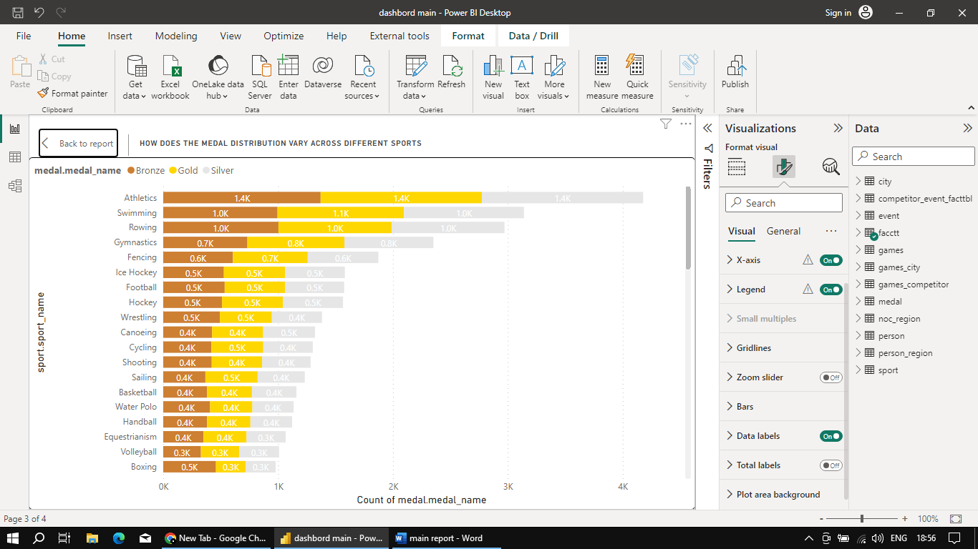

medal distribution for the top 5 and last 5 sports in the Olympics, including the details of gold, silver, and bronze medals:

**Top 5 Sports:**

**Athletics:**

* Athletics has been a prominent sport in the Olympics, with a significant number of medals awarded across its events. It has seen a balanced distribution of gold, silver, and bronze medals, with 1404 gold medals, 1404 silver medals, and 1370 bronze medals.

**Swimming:**

* Swimming is another major sport in the Olympics, known for its wide variety of events. It has seen a substantial distribution of medals, with 1100 gold medals, 1045 silver medals, and 995 bronze medals.

**Rowing:**

* Rowing is a traditional Olympic sport that has consistently awarded medals over the years. It has a distribution of 987 gold medals, 981 silver medals, and 1003 bronze medals.

**Gymnastics:**

* Gymnastics showcases incredible athleticism and artistic skills. The sport has awarded 844 gold medals, 775 silver medals, and 733 bronze medals.

**Fencing:**

* Fencing is a sport of precision and strategy, and it has contributed to the Olympic medal count with 651 gold medals, 615 silver medals, and 607 bronze medals.

**Last 5 Sports:**

**Croquet:**

* Croquet is a less common sport in the Olympics, with a total of 8 medals awarded. It includes 4 gold medals, 2 silver medals, and 2 bronze medals.

**Military Ski Patrol:**

* Military Ski Patrol is a historical sport that was part of the Olympics. It has awarded 12 medals in total, evenly distributed with 4 gold, 4 silver, and 4 bronze medals.

**Racquets:**

* Racquets is another sport with a limited presence in the Olympics, awarding a total of 11 medals. It includes 3 gold medals, 3 silver medals, and 4 bronze medals.

**Basque Pelota:**

* Basque Pelota is a relatively rare sport in the Olympics, awarding 3 medals in total, all of which are gold medals.

**Jeu De Paume:**

* Jeu De Paume, a historic sport played with a ball and racket, has only one appearance in the Olympics, resulting in 3 medals. It includes 1 gold, 1 silver, and 1 bronze medal.

### 16. How many regions or NOCs participate in each Olympic Games?

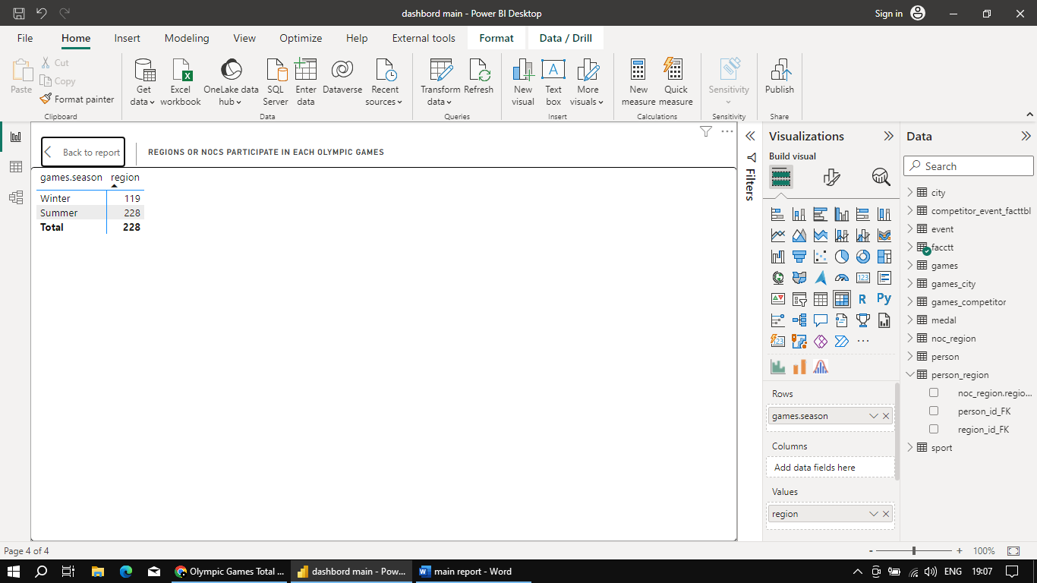

there are 228 National Olympic Committees (NOCs) that participate in the Summer Olympic Games, and there are 119 NOCs that participate in the Winter Olympic Games. These numbers represent the total number of regions or countries that participate in each respective type of Olympic Games.

### 17. Which regions have the highest number of participants in the Olympics?

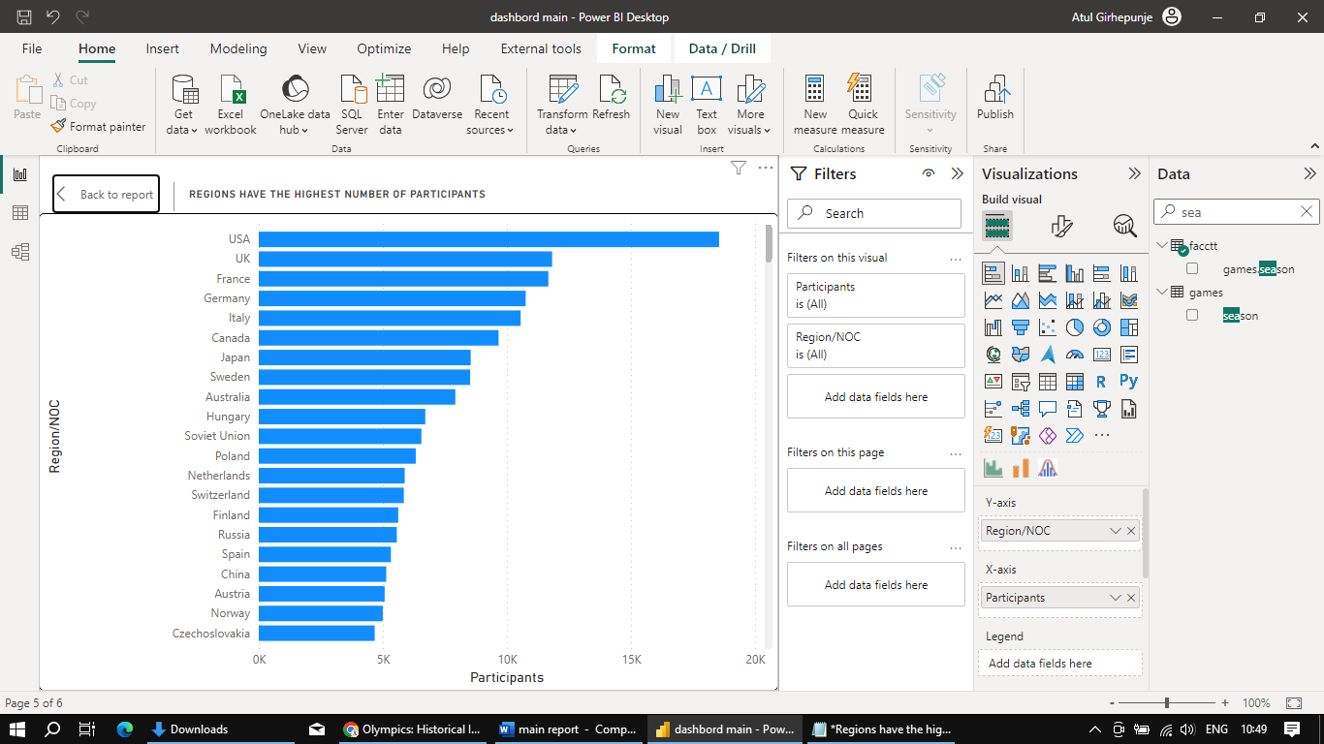

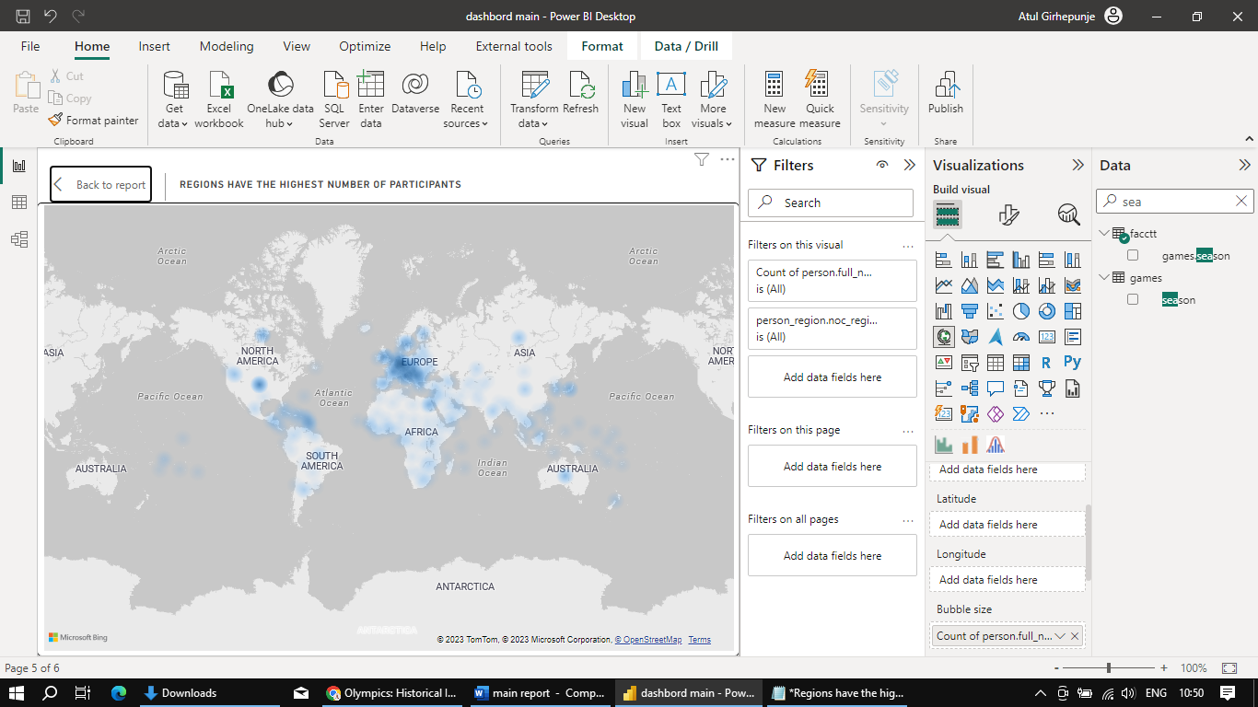

•  **United States (USA) - 18,551 participants:** A sports powerhouse with a rich history and strong infrastructure.

• **United Kingdom (UK) - 11,821 participants:** Sporting heritage and dedication lead to significant representation.

• **France - 11,670 participants:** Diverse sports excellence and historic success contribute.

• **Germany - 10,757 participants:** Strong tradition, investment, and sports culture drive participation.

• **Italy - 10,552 participants:** Historical prowess and commitment to talent development play a role.

Above heatmap shows European countries have a strong presence in the Olympics due to factors like rich sports history, investment in athlete development, emphasis on diverse sports, and well-established sports infrastructure. The UK, France, Germany, Italy, Sweden, Russia, Spain, Netherlands, Switzerland, and Finland stand out with notable participation and achievements across various Olympic disciplines.

### 18. What is the distribution of medals among different regions?

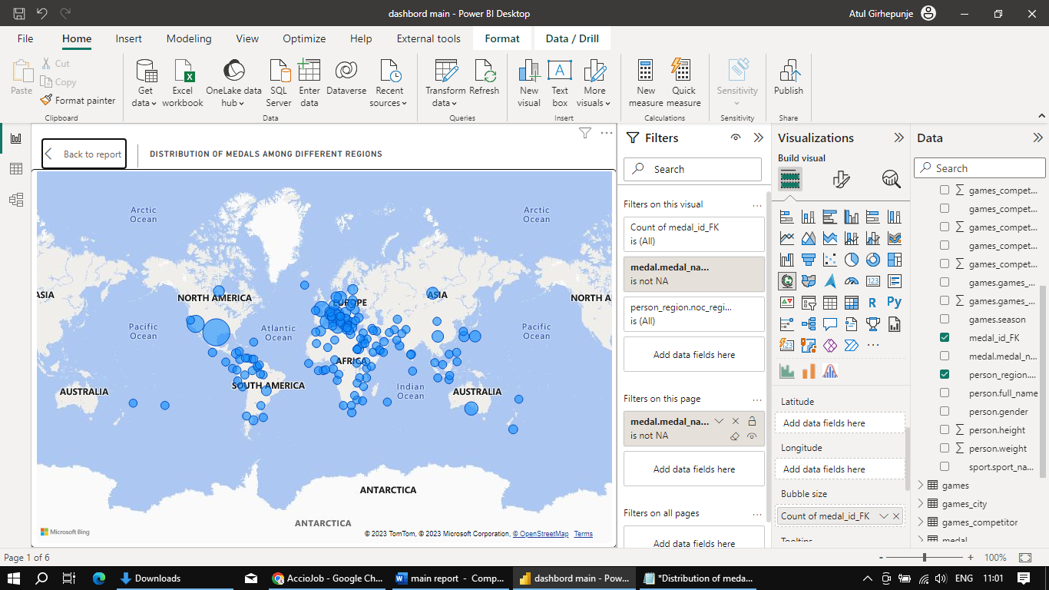

1. **USA**: The United States holds the top position due to its consistent dominance across all three medal categories. With a strong sporting tradition and investment in athlete development, the USA has consistently excelled in a wide range of sports, resulting in a high number of gold, silver, and bronze medals.
2. **Soviet Union**: The Soviet Union's historical presence and focus on sports excellence allowed it to accumulate a significant number of gold and silver medals. The country's robust sports infrastructure and rigorous training programs contributed to its success in various disciplines.
3. **Germany**: Both West Germany and East Germany have contributed to Germany's strong position in the medal tally. Their combined efforts in sports like athletics, gymnastics, and winter sports have resulted in a balanced distribution of gold, silver, and bronze medals.
4. **UK**: The United Kingdom's strong presence in sports such as cycling, rowing, and athletics has earned it a notable silver medal count. With its rich sporting history and investments in high-performance programs, the UK consistently performs well on the global stage.
5. **France**: France's strong showing in sports like fencing, judo, and football has contributed to its position in the top 5. A balanced distribution of gold, silver, and bronze medals highlights its competitive edge in multiple disciplines.

# **Power BI Report Snap shots**

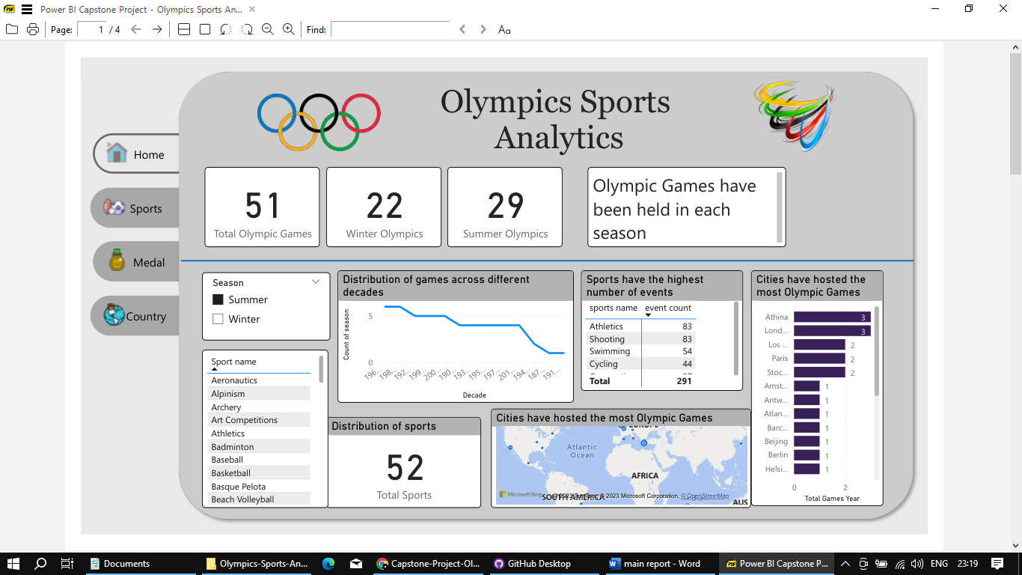

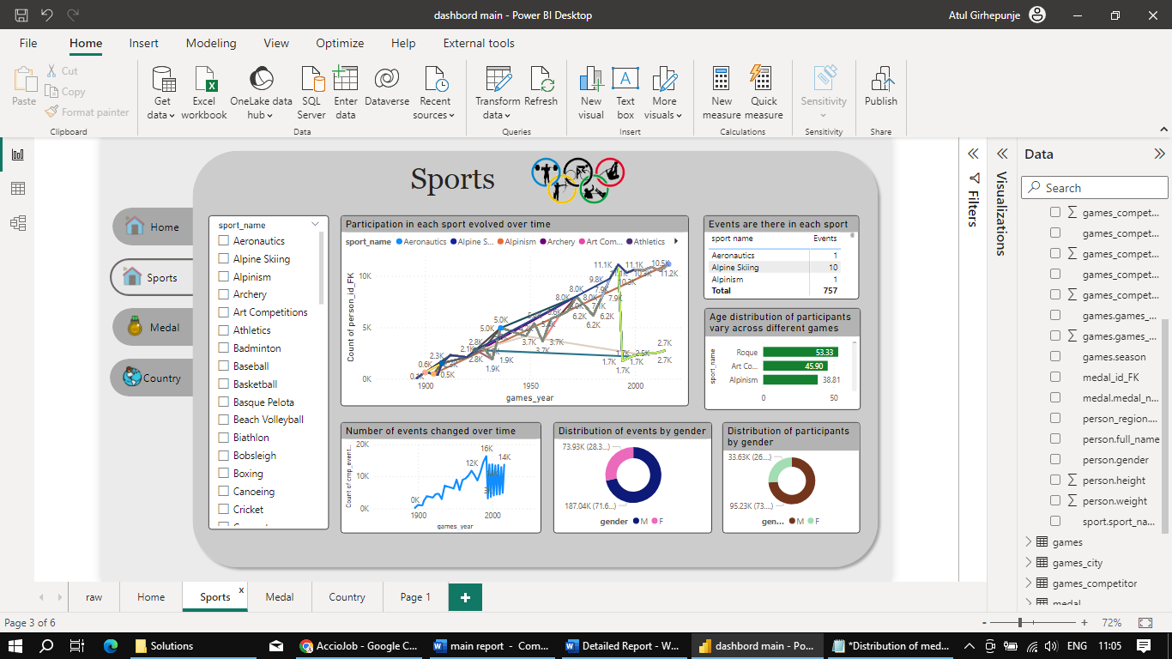

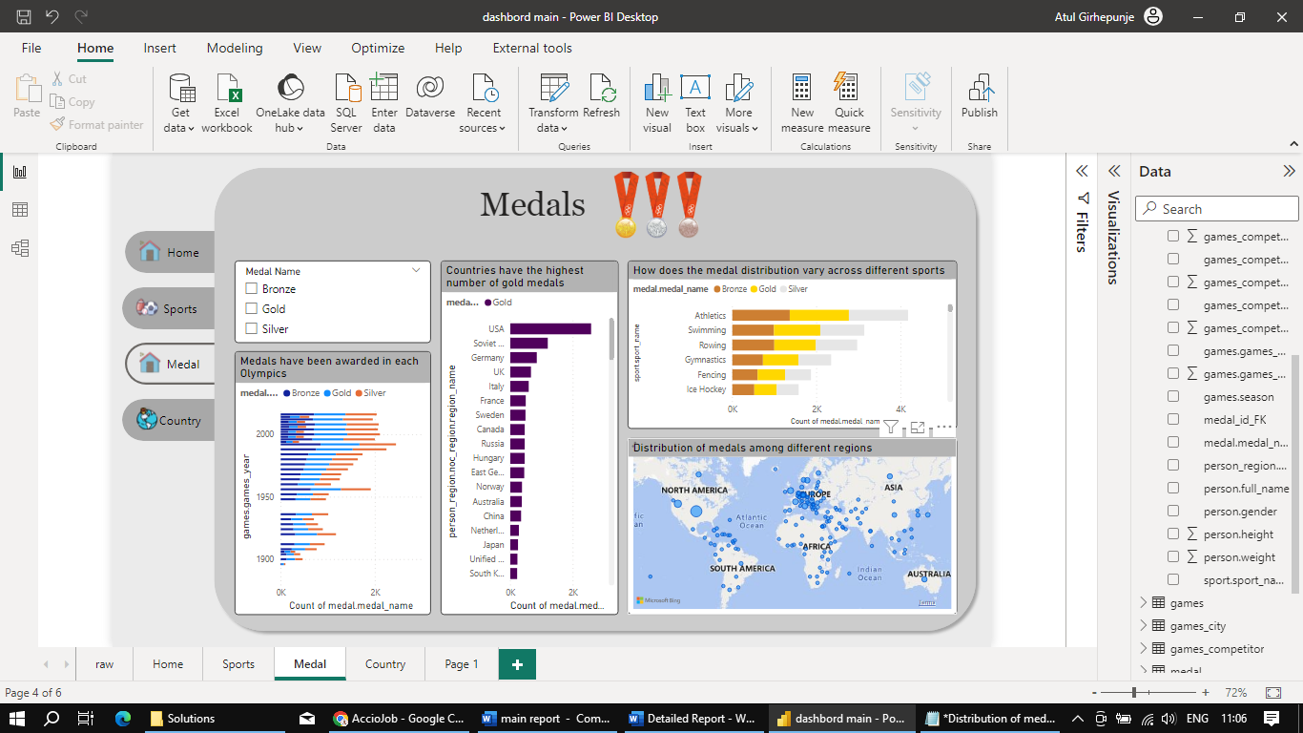

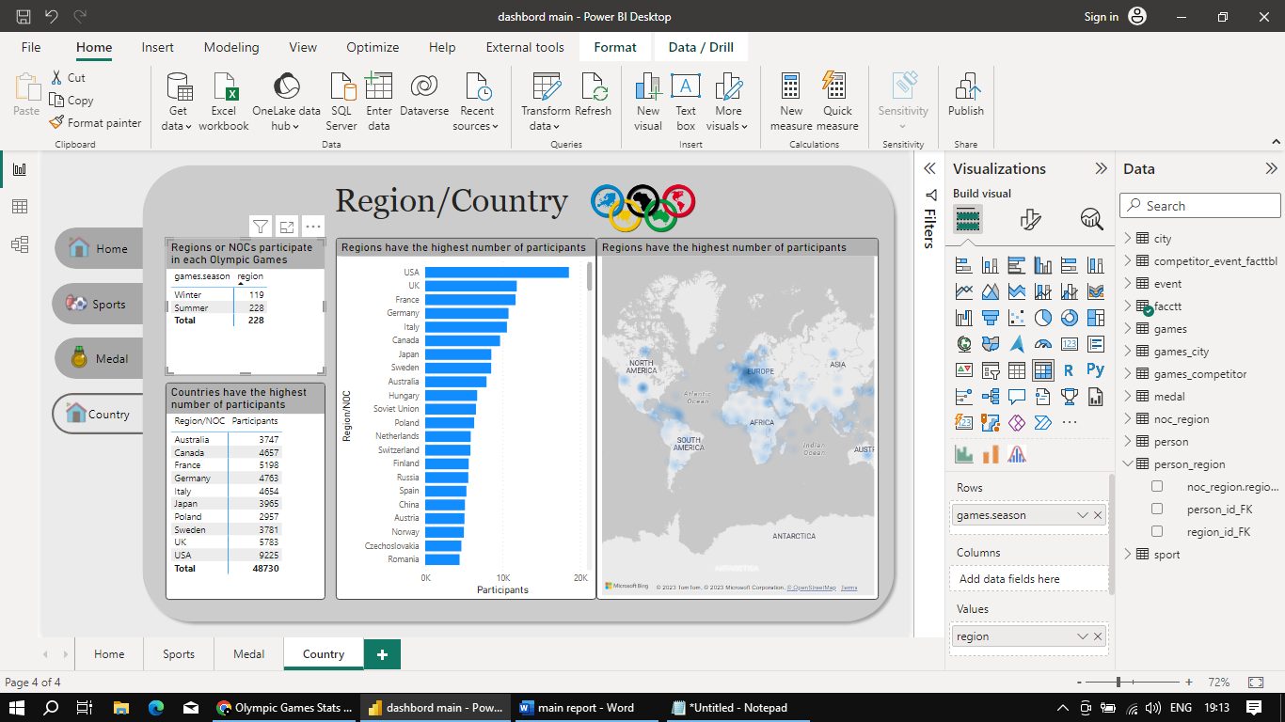

Conclusion

1. **Dominance of the USA:** The United States stands out as a dominant force in the Olympics, leading in terms of total medals, gold medals, and overall participation. Its diverse sports culture, investment in athlete development, and strong infrastructure contribute to its exceptional performance.
2. **European Powerhouses:** European countries like the UK, Germany, France, and Italy have consistently performed well in the Olympics. Their rich sporting heritage, comprehensive athlete training, and commitment to sports excellence have led to significant representation and medal counts.
3. **Soviet Union's Legacy:** The Soviet Union's historical presence is evident in its substantial medal tally. Its focus on athletic prowess across various disciplines has left a lasting impact on the Olympic landscape.
4. **Balance in Medal Distribution:** While the USA dominates in terms of total medals, the distribution of medals across gold, silver, and bronze highlights a more balanced representation among different regions, reflecting the diversity and global nature of the Olympics.
5. **Evolution of Participation:** Over time, participation in the Olympics has grown significantly, with more countries and athletes taking part in various sports. This expansion underscores the increasing global interest in sports and the importance of the Olympic movement.
6. **Sports Diversity:** The Olympics encompass a wide array of sports that cater to different talents and abilities. From traditional events like athletics, swimming, and gymnastics to niche disciplines like fencing and rowing, the Games showcase the breadth of human athletic achievement.
7. **Efforts for Gender Equality:** While disparities in gender distribution still exist, efforts to promote gender equality in the Olympics are evident. Female participation has been increasing, and there are ongoing initiatives to ensure fair representation for women in sports.
8. **Historical Significance:** The Olympics serve as a historical record of human athletic achievement, reflecting the changing times, technological advancements, and shifts in global dynamics.
9. **Sports Culture Impact:** Countries with strong sports cultures tend to have higher participation rates and better overall performance. Investments in sports infrastructure, grassroots programs, and high-performance training contribute to success in the Games.
10. **Unity Through Sports:** The Olympics bring nations together in the spirit of friendly competition, mutual respect, and shared values. Despite geopolitical tensions, the Games serve as a platform for fostering international camaraderie and understanding.

In summary, the Olympic Games are a testament to the dedication, skill, and unity of athletes from around the world. The data provides valuable insights into the evolution of the Games, the impact of sports on societies, and the ongoing pursuit of excellence in the spirit of global harmony.